Minutes
on the 1st Steering Group (Kick-off) Meeting
of
PA4 – To Restore and Maintain the Quality of Waters – of the EUSDR
on 21 June 2011, Bratislava, Slovak Republic
- Objective of the meeting

Setting up a Steering Group for the implementation of the EU Strategy for the Danube Region with discussion on steering procedure (overview on EUSDR, information on financing, review of Rules of Procedure, Targets of the Priority Area 4, further operational steps)

The meeting was attended by representatives of Danube countries HU, SK, DE, AT, RO, SI, RS, HR except CZ, BG, BA, UA, ME,MD and by representatives of EC, ICPDR (see the participant list). The meeting took place in Water Research Institute of the Slovakian Ministry of Environment, Bratislava, on 21 June 2011.

The Kick-off Meeting Agenda included the following items:

10:00 – 10:10 Welcome speech (SK František Koločány)
10:10 – 10:30 Presentation of the proposed agenda, approval of the agenda (Lead PAC4 SK)
10:30 – 11:00 Presentation of the financing of EUSDR (Lead PAC4 SK)
11:00 – 12:00 Presentation of decision making on the proposed Rules of Procedure of the Steering group (Lead PAC4 HU)
13:00 – 14:00 Presentation of PA 4: tasks, objectives and targets (Lead PAC4 HU)
14:00 – 15:00 Presentation of the Implementation Plan of PA4, with special regard to actions broken down by operational steps and targets (Lead PAC 4 HU)

15:00 – 15:30 Conclusion, Closure of the meeting

The documents presented by PACs at rhe Kick-off meeting as pre meeting documents are available at
www.danube-region.eu website.
The later agreed and approved documents by SG will be sent out continuously:

There are documents already available:
EUSDR PA4 pptx
New_RoP_for_EUSDR_ PA4_Steering_draftversion docx
Steering Group Members_void_for_1SG_21 June 2011 doc
Overview_by PAC4_SK_DS1 ppt
Financing overview_by PAC4_SK_DS2 ppt
PA4_projectsheet_void xls
Targets_1SG_21 June 2011 doc
activities doc
Reg form_EUSDR docx
PA4_Invitation_Agenda_1SG_21 June 2011_Final docx
Finance_1SG_21 June 2011 doc

2. Presentation of the proposed agenda, approval of the agenda
The proposed agenda was unanimously approved.
3, Presentation on overview of EUSDR
As first presentation the EU strategy for Danube Region was provided as follows:
- historical overview included the cooperation between Danubian countries, basic and background documents supporting the macro-regional cooperation.
- European Union Strategy for Danube Region, Action plan and Joint Declaration by the country representatives responsible for the coordination the Pillar B “Protecting the Environment in the Danube Region”
- The basic responsibility of PACs and the aim of the 1st kick-off meeting were presented.
4. Presentation of the financing of EUSDR
The basic idea in the financing was presented, which is based on the slogan: No New Funds. Some examples of existing funds, which may provide possible supporting programs for EU Strategy for Danube Region, were presented: Structural Funds, IPA, ENPI, EIB, RENA, UENP, UNDP, and NATO. PACs informed about preparing deep analysis, which will be presented on the next steering group meetings following changes and possibilities.
5. Presentation the decision making process and the proposal on Rules of Procedures of the Steering Group
A new draft version on Rules of Procedures of the Steering Group PA4 was disseminated at spot to discuss. Some participants being SG members of PA5 too, mentioned and proposed partly adaptation of PA5 Rules of Procedures, because the crucial points of a PA rules are already discussed before and to be avoid any parallel work they suggest to shift the most suitable paragraphs into PA4 rules
The representative persons from EC noticed that it is not necessary to approve Rules of Procedures at this meeting, it can be approved later, after amendment taken by e-mail.
After negotiations participants agreed on the following:
- Rules of Procedures PA4 would be based on Rules of Procedures PA5 (to be avoid the already discussed and more or less agreed rules)
- Rules of Procedures would be sent by e-mail and also its adoption will be provided by the same way

6. Presentation of PA4 targets
Targets announced as example in the Communication on the EU Strategy for Danube Region concerning PA4 were presented. After a rapid and effective discussion (AT, ICPDR, HU, RO) the steering group proposed and adopted the following new targets:
- Achieve the management objectives set out in the Danube River Basin Management Plan;
- Reduce the nutrient levels in the Danube River to allow the recovery of the Black Sea ecosystems to conditions similar to 1960s;
- Elaborate a Danube Delta Analysis Report by 2013 as a step towards completion of the Delta management Plan, which shall be adopted by 2015;
- Elaborate, adopt and implement sub basin management plans, such as Sava, Tisza and Prut sub basins
- Secure viable populations of Danube sturgeon species (to be discussed with PA6)

7. Presentation of the Implementation Plan of PA4, with special regard to action broken down by operational steps
The actions concerned PA4 announced in the Action Plan were presented. The Steering Group discussed the different responsibility levels during the implementation process. Agreed on the common but technically shared responsibilities between HU and SK in the field of overall coordination and reporting, action leaders and action partners were nominated and agreed as follows:

No | ACTIONS | PACs responsibility  for actions | Action Leader  for action implementation | Action Partners  contributing  in implementation  (may vary in processing time)
1 | To implement fully the Danube River Basin Management Plan” | SK/HU | ICPDR Secretariat | All Danube region  countries
2 | To greatly strengthen cooperation at sub-basin level | HU/SK | ICPDR Secretariat | All Danube region  countries  Sava Commission  Tisza Group
3 | To continue to invest in and support the information collection systems already developed by ICPDR | SK/HU | ICPDR Secretariat | All Danube region  countries
4 | To continue boosting major investments in building and upgrading urban wastewater treatment facilities across the Danube Basin, including measures to build capacity at the regional and local level for the design of such infrastructure | HU/SK | ICPDR Secretariat | All Danube region  countries  Associations of water suppliers
5 | To establish buffer strips along the rivers to retain nutrients and to promote alternative collection and treatment of waste in small rural settlements | HU/SK | HU | All Danube region  countries  ICPDR Expert Groups
6 | To foster and develop an active process of dialogue and cooperation between authorities responsible for agriculture and environment to ensure that measures are taken to address agricultural pollution | SK/HU | SK | All Danube region  countries  NGOs
7 | To legislate at the appropriate level to limit the presence of phosphates in detergents | HU/SK | ICPDR Secretariat | All Danube region  countries
8 | To treat hazardous substances and contaminated sludge with the newest and best available technology and to develop and promote remediation measures for hazardous producing or abandoned industrial sites and waste deposits | HU/SK | HU | All Danube region  countries
9 | To assure the proper control and progressive substitution of substances that are considered problematic for Danube Region | SK/HU | ICPDR Secretariat | All Danube region  countries
10 | To reduce existing water continuity interruption for fish migration in the Danube river basin | SK/HU | ICPDR Secretariat | All Danube region  countries
11 | To promote measures to limit water abstraction | HU/SK | HU | All Danube region  countries  Universities  Climate Centres
12 | To strengthen general awareness and facilitate exchange of good practice in integrated water management issues in the Danube Basin among decision-makers at all levels and among the population of the Region | HU/SK | ICPDR Secretariat | All Danube region  countries
13 | To promote measures aimed at reducing knowledge deficits, developing and transferring tools, methods and guidelines concerning the safeguarding of drinking water supply | SK/HU | SK | All Danube region  countries,  Associations of water suppliers
14 | To further strengthen Integrated Coastal Zone Management (ICZM) and Maritime Spatial Planning (MSP) practices on the Western shores of the Black Sea | SK/HU | RO | Ukraine,  Moldova  WWF
(Only the grey column may be added with new partners or be amended. The white background column contents are already agreed.)
Form of list of projects fitted to EUSDR:
Consecutively the form of list of ongoing and planned projects and the criteria for flagship project labeling were presented and discussed. The following project sheet was adopted.
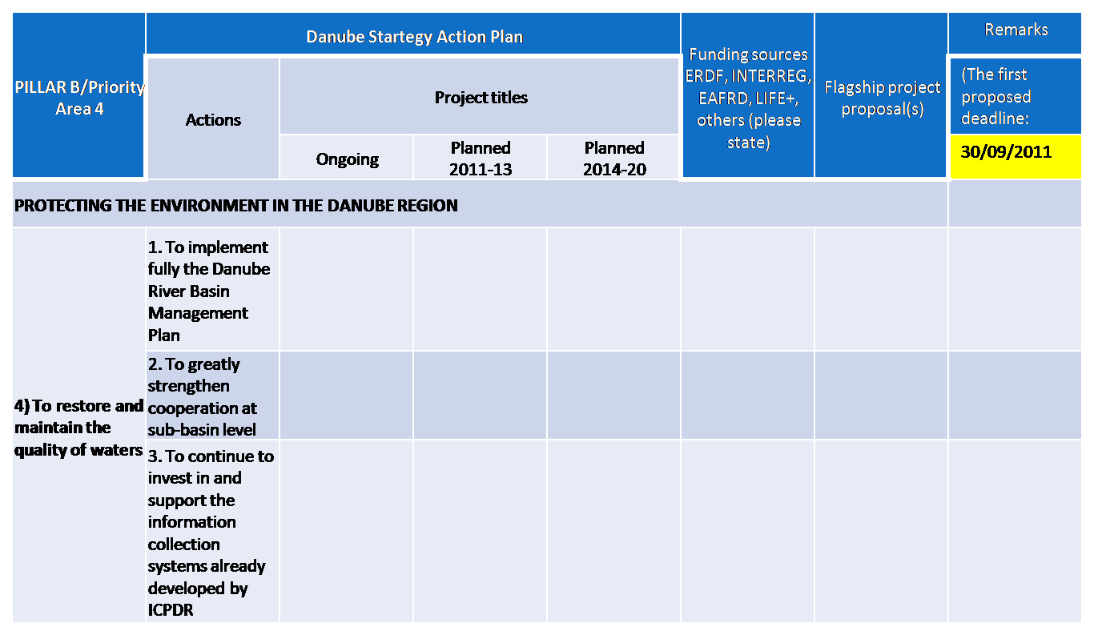
Criteria for flagship project labeling
Flagship project shall
- meet the targets of the relevant Priority Area(s),
- be realistic (technically feasible),
- provide added value to the Strategy,
- provide a win-win solution,
- be an on-going project with macro-regional effect/relevance,
- be potentially bankable as planned project (has project leader, deadline, partners and budget),
- be approved by the Steering Group.

Since there were no objections signed by the participants, the criteria were adopted.
8. Next steps (by end of 2011)
Proposal of next steps (by the end of 2011) was presented. Proposal was discussed and adopted with modification according to recommendation of the representative person form EC on change in timing.
Next steps:
- Finalization of targets by the end of June,
- Finalization of flagship labelling criteria by the end of June,
- Sending the PA4 relevant on-going project’s sheet to PACs4 by the end of September,
- Sending the PA4 relevant planned project’s sheet (2011-13) outlooking to PA5 and PA6 to PACs4 by the end of July (living sheets),
- The first selection of flagship projects (proposal from Action Leaders and be sent to PACs4) by 15 October
- The next Steering Group Meeting will be organized by 15 October (the venue is potentially Budapest)

9. Conclusions (at the spot)
- Rules of Procedures – not agreed,
- Targets – agreed
- Activities – agreed
- Form of list of projects fitted to EUSDR (project sheet):– agreed
- Criteria for flagship labeling –agreed
- Next steps (by end of 2011) - agreed
Renata Magulova, Laszlo Perger PACs4

