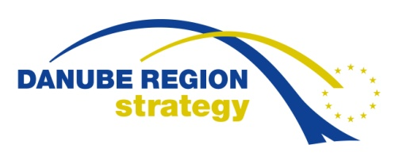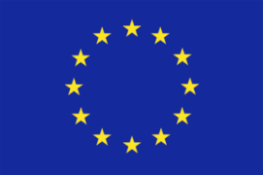

Obligatory Registration Form

Drought and Water Scarcity
Organised by EUSDR, PA4 “Water Quality”

International Conference

Bratislava

17 - 18 May 2016

Name and surname:
Name of company:
Address of company:
Phone: cell phone:
E-mail:
Gala Dinner* YES NO
*circle appropriate option

Seal and signature

Please, send filled obligatory registration form to the following email addresses not later than May 11, 2016:
alena.kurecova@vuvh.sk; andrea.vranovska@vuvh.sk

