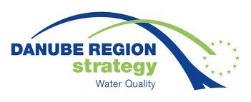

Registration Form

Securing Drinking Water Supply

the international workshop organized within the
EU Strategy for the Danube Region (EUSDR), Priority Area 4 “Water Quality”

Vedecký park UK (Comenius University Science Park), Ilkovičova 8, Bratislava

22 November 2023

Name and surname:
Name of company:
Address of company:
Phone:
E-mail:
Vegetarian: Yes/No (underline right option)

Please, send filled registration form to the following email addresses not later than 16 November, 2023:
dana.vrablikova@vuvh.sk; andrea.vranovska@vuvh.sk

Please note that due to limited space of the venue registrations will be processed on first-come first-serve basis.

